**MCV4U Intersections Unit Assignment**

**Jin Hyung Park**

1. **The equation of a line can be determined using two points on the line.**
2. Find the vector, parametric and symmetric equations of the line through the points (–2, 3, 1) and (1, 4, –2).

* Vector Equation:
  + The point vector is [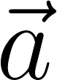](https://www.codecogs.com/eqnedit.php?latex=%5Cvec%7Ba%7D#0)
  + The direction vector is [](https://www.codecogs.com/eqnedit.php?latex=%5Cvec%7Bb%7D%3D(1-(-2)%2C4-3%2C-2-1)%3D%5Cvec%7Bb%7D%3D(3%2C1%2C-3)#0)
  + Substitute  and  into  is the following.
    - [](https://www.codecogs.com/eqnedit.php?latex=%5Bx%2Cy%2Cz%5D%3D%5B-2%2C3%2C1%5D%2Bt%5B3%2C1%2C-3%5D#0)
  + Therefore, the vector equation that passes through the given points is [](https://www.codecogs.com/eqnedit.php?latex=%5Bx%2Cy%2Cz%5D%3D%5B-2%2C3%2C1%5D%2Bt%5B3%2C1%2C-3%5D#0).
* Parametric Equation:
  + Rewrite the vector equation, [](https://www.codecogs.com/eqnedit.php?latex=%5Bx%2Cy%2Cz%5D%3D%5B-2%2C3%2C1%5D%2Bt%5B3%2C1%2C-3%5D#0), as the following.
  + [](https://www.codecogs.com/eqnedit.php?latex=%5B-2%2C3%2C1%5D%2Bt%5B3%2C1%2C-3%5D%3D(-2%2C3%2C1)%2B(3t%2C1t%2C-3t)#0)
  + [](https://www.codecogs.com/eqnedit.php?latex=x(t)%3D-2%2B3t%2C%20y(t)%3D3%2B1t%2C%20z(t)%3D1-3t#0)
* Symmetric Equation:
  + [](https://www.codecogs.com/eqnedit.php?latex=x(t)%3D-2%2B3t%2C%20y(t)%3D3%2B1t%2C%20z(t)%3D1-3t#0)
  + [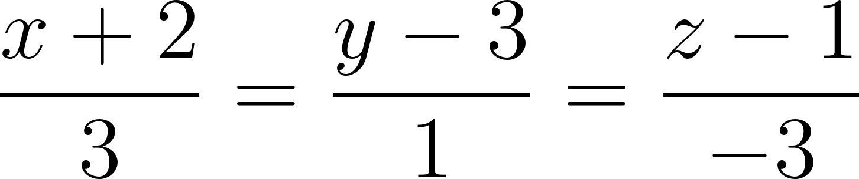](https://www.codecogs.com/eqnedit.php?latex=%5Cfrac%7Bx%2B2%7D%7B3%7D%3D%5Cfrac%7By-3%7D%7B1%7D%3D%5Cfrac%7Bz-1%7D%7B-3%7D#0)

1. Explain the features of the equations of a line that is parallel to the xz plane, but does not lie on the plane, and is not parallel to any of the axes. Include a LanGraph of your line.

* Features
  + Parallel to xy plane when the given Direction Vector is
  + Not on the xy plane when the given Position Vector is
  + Not parallel to 3 axes when the given Direction vector is
* Equations
  + [](https://www.codecogs.com/eqnedit.php?latex=%5Bx%2Cy%2Cz%5D%3D%5B-2%2C3%2C1%5D%2Bt%5B3%2C1%2C-3%5D#0)

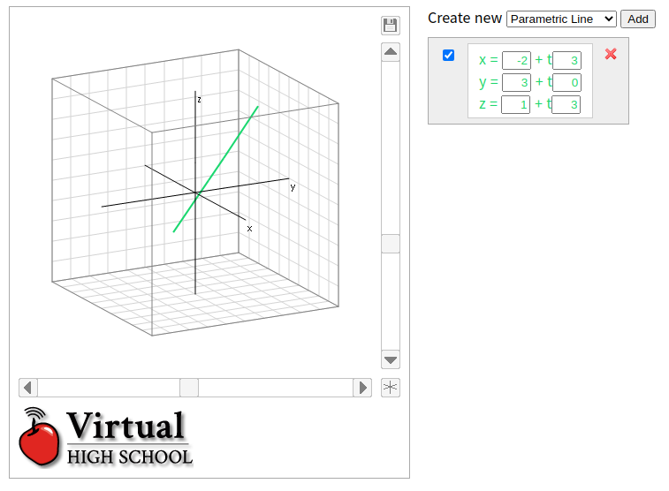

**2. Two given lines are either parallel, skew, or intersecting.**

1. Determine, if there is one, the point of intersection of the lines given by the equations.

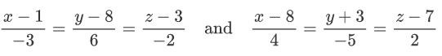

Given that, the point of intersection of the lines given by the equations, we can introduce variable t and s to get each point’s equation.

Introduce t variable: [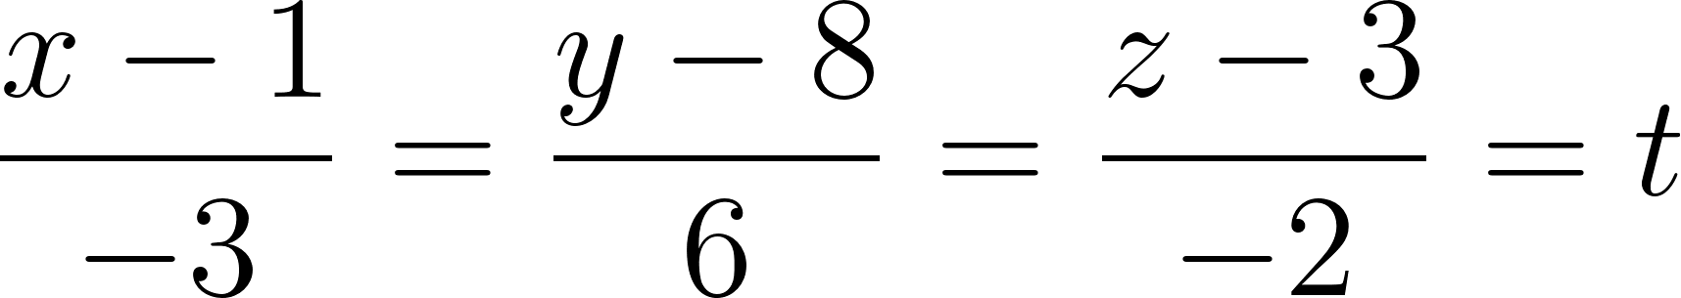](https://www.codecogs.com/eqnedit.php?latex=%5Cfrac%7Bx-1%7D%7B-3%7D%3D%5Cfrac%7By-8%7D%7B6%7D%3D%5Cfrac%7Bz-3%7D%7B-2%7D%3Dt#0)

[](https://www.codecogs.com/eqnedit.php?latex=x%3D-3t%2B1%2C%20y%3D6t%2B8%2C%20z%3D-2t%2B3#0)

Introduce s variable: [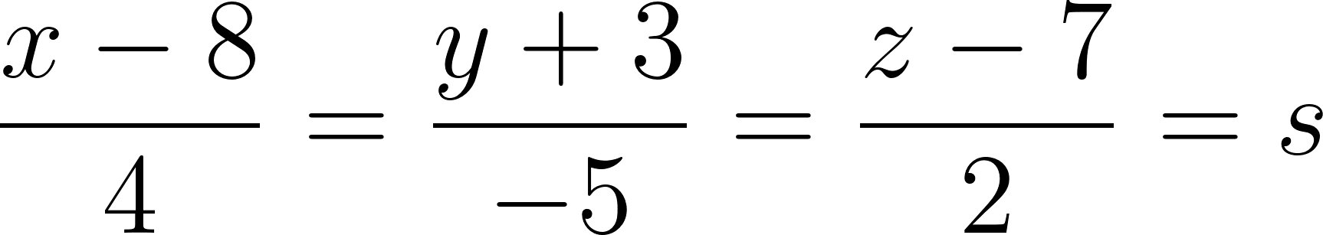](https://www.codecogs.com/eqnedit.php?latex=%5Cfrac%7Bx-8%7D%7B4%7D%3D%5Cfrac%7By%2B3%7D%7B-5%7D%3D%5Cfrac%7Bz-7%7D%7B2%7D%3Ds#0)

[](https://www.codecogs.com/eqnedit.php?latex=x%3D4s%2B8%2C%20y%3D-5s-3%2C%20z%3D2s%2B7#0)

Then, we can say that two lines will intersect.

[](https://www.codecogs.com/eqnedit.php?latex=-3t%2B1%3D4s%2B8%20%3D%3E%203t%2B4s%3D-7#0) -> (1)

[](https://www.codecogs.com/eqnedit.php?latex=6t%2B8%3D-5s-3%20%3D%3E%206t%2B5s%3D-11#0) -> (2)

Use (2), (3) to solve the variables.

->

-> (2)

Substitute into (1) equation:

Thus, the point of intersection is

1. Give the equations of two lines that meet at the point (–1,5, 2) and which meet at right angles, but do not use that point in either of the equations. Explain your reasoning and include a LanGraph of your line.

The direction vectors of two perpendicular lines can be the following.

[](https://www.codecogs.com/eqnedit.php?latex=%5Cvec%7Bb1%7D%3D%5B1%2C2%2C3%5D%2C%20%5Cvec%7Bb2%7D%3D%5B-1%2C2%2C-1%5D%2C%20(%5Cvec%7Bb1%7D%5Ccdot%5Cvec%7Bb2%7D)%3D0#0)

The two lines must intersect the given points at (-1,5,2). Thus, we can write the following.

We can consider the following cases for each line to get a new position vector that intersects at (-1,5,2).

Using new position vectors,

Using new position vectors,

**3. The equation of a plane can be determined using three points on the plane.**

* Find the vector, parametric and general equations of the plane through the points (2, –3, 1), (3, 1, 6), and (5, –1, 2).
  + The equation of a plane can be determined using these points on the plane.
    - [](https://www.codecogs.com/eqnedit.php?latex=%5Cvec%7Ba%7D%7Bb%7D%3D(3-2)i%2B(1%2B3)j%2B(6-1)k#0)
    - [](https://www.codecogs.com/eqnedit.php?latex=%5Cvec%7Ba%7D%7Bc%7D%3D(5-2)i%2B(-1-3)j%2B(2-1)k#0)
  + The vector equation is the following.
    - [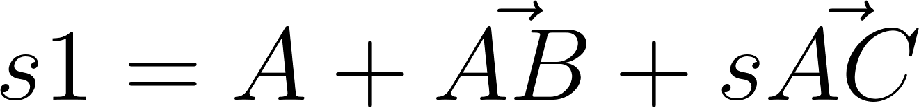](https://www.codecogs.com/eqnedit.php?latex=s1%3DA%2B%5Cvec%7BAB%7D%2Bs%5Cvec%7BAC%7D#0)
  + The parametric equation is the following.
  + The general equation is the following.
    - [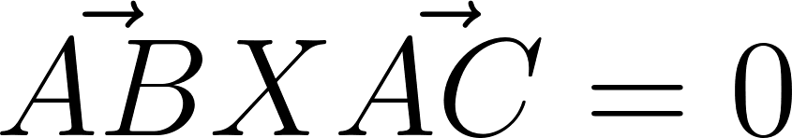](https://www.codecogs.com/eqnedit.php?latex=%5Cvec%7BAB%7DX%5Cvec%7BAC%7D%3D0#0), Two directions are perpendicular.

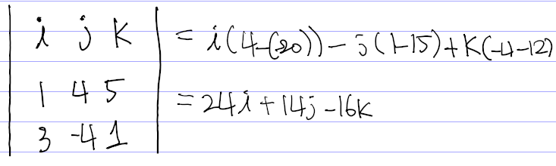

* Give the equation of a plane that crosses the axes at points equidistant from the origin. Explain your reasoning and include a LanGraph of your plane.
  + , ,
  + When such a plane has three points; , it crosses the three axes at the points equidistant from the origin.

**4. A line can either lie on a plane, lie parallel to it, or intersect it.**

1. Determine, if there is one, the point of intersection between the line given by the following equation and plane.

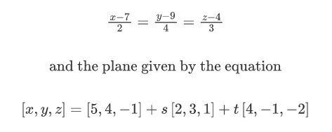

We can let formulas as the following.

Thus, we can say the following:

Thus, we can substitute (1) into (2) as follows.

Substitute into the formula.

Thus, the points for the point of intersection. We can write as the following.

Thus, the answer is

1. Determine the angle between the line and the plane.

From the given We can say the direction vector is [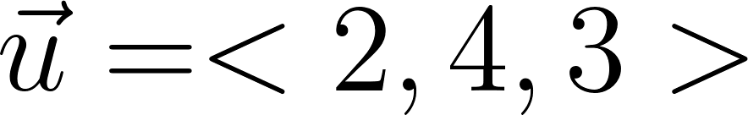](https://www.codecogs.com/eqnedit.php?latex=%5Cvec%7Bu%7D%3D%3C2%2C4%2C3%3E#0).

We can get the normal vector by calculating the following.

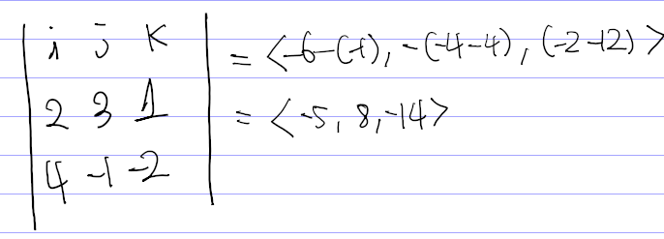

Thus, [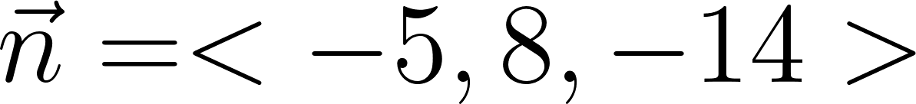](https://www.codecogs.com/eqnedit.php?latex=%5Cvec%7Bn%7D%3D%3C-5%2C8%2C-14%3E#0)

1. Give the equation of a plane and three lines, one of which is parallel to the plane, one of which lies on the plane, and one of which intersects the plane. Explain your reasoning and include a LanGraph.

**5. The angle between two planes can also be determined.**

1. Find the angle between the planes given by the equations.

Let to be the normal vector of the plane n1.

Let to be the normal vector of the plane n2.

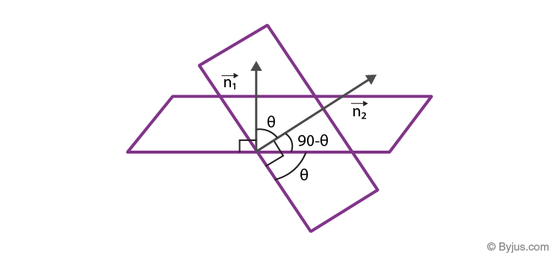

Let [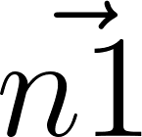](https://www.codecogs.com/eqnedit.php?latex=%5Cvec%7Bn1%7D#0) and [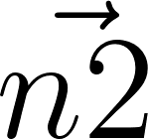](https://www.codecogs.com/eqnedit.php?latex=%5Cvec%7Bn2%7D#0) be the two normal to the planes aligned to each other at an angle θ. From the above figure, we learnt that the angle between planes are the same as the angle between the normal vectors.

The angle between the planes are the same as the angle between the normal vectors.

[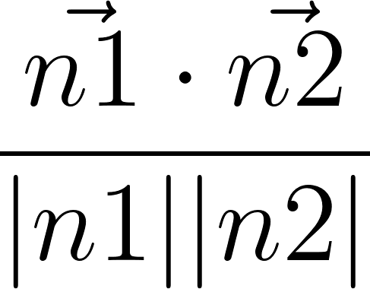](https://www.codecogs.com/eqnedit.php?latex=%5Cfrac%7B%5Cvec%7Bn1%7D%5Ccdot%5Cvec%7Bn2%7D%7D%7B%7Cn1%7C%7Cn2%7C%7D#0)=

1. Give the equations of two planes that meet at a 90° angle. Explain your reasoning and include a LanGraph of your planes.

For the first plane, let us have [](https://www.codecogs.com/eqnedit.php?latex=%5Cvec%7Bn1%7D#0). In this case, the normal vector of the second plane, [](https://www.codecogs.com/eqnedit.php?latex=%5Cvec%7Bn2%7D#0), should be perpendicular to [](https://www.codecogs.com/eqnedit.php?latex=%5Cvec%7Bn1%7D#0).

We can get the value that [](https://www.codecogs.com/eqnedit.php?latex=%5Cvec%7Bn2%7D#0) can be since the following.

[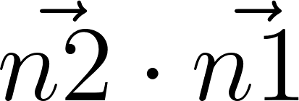](https://www.codecogs.com/eqnedit.php?latex=%5Cvec%7Bn2%7D%5Ccdot%5Cvec%7Bn1%7D#0)

Two planes are normal vectors with the following.

where can be any value

where can be any value

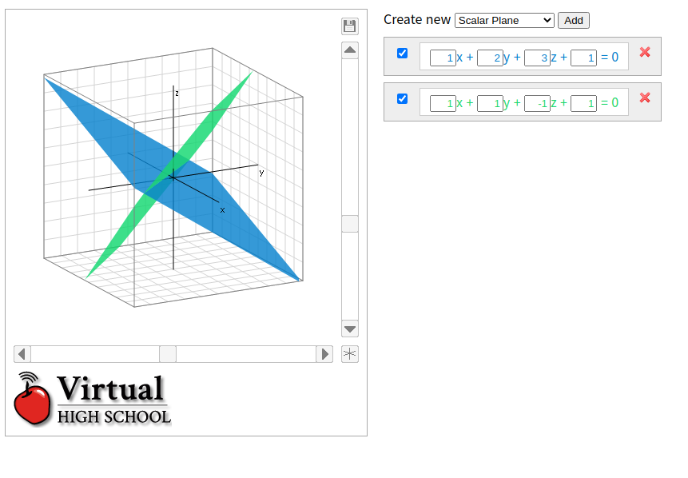

**6. A third plane can be found that passes through the line of intersection of two existing planes.**

1. Two planes are given by the equations and . Find the scalar equation of the plane that passes through the line of intersection of these two planes, and also passes through the point

Let the plane through the intersection above the plane is the following.

Substitute variables with given points,

Thus, we can write the scalar equation of a plane satisfying the conditions above is the following.

1. Give the equations of two planes. Create a third plane that passes through the line of intersection of the original two and which is parallel to the x-axis. Explain your reasoning and include a LanGraph of your planes.

To solve the problem, let two planes do the following.

The third plane passing through the line of intersection of the two planes can be the following.

Given that the plane is parallel to x-axis (ex. (1,0,0))

Substitute k to the equation to solve it.

So, the equation of the plane is the following.

**7. Three planes can intersect in a number of different ways. For each of the combinations below, find the single point of intersection if there is one. If there isn't, explain how the planes do intersect.**

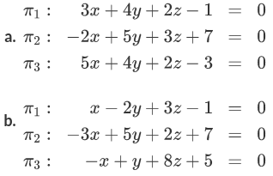

1. [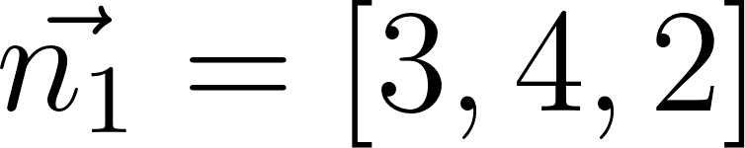](https://www.codecogs.com/eqnedit.php?latex=%5Cvec%7Bn_1%7D%3D%5B3%2C4%2C2%5D#0)

[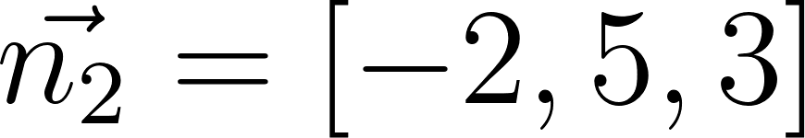](https://www.codecogs.com/eqnedit.php?latex=%5Cvec%7Bn_2%7D%3D%5B-2%2C5%2C3%5D#0)

[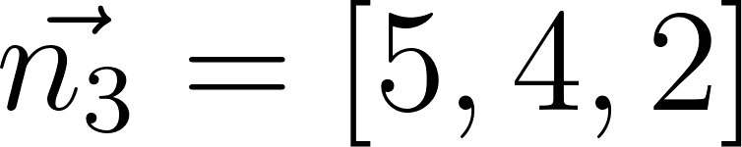](https://www.codecogs.com/eqnedit.php?latex=%5Cvec%7Bn_3%7D%3D%5B5%2C4%2C2%5D#0)

We know the fact that if the scalar triple product is zero, it means the vectors are coplanar to each other. Thus, we are going to verify whether the given vectors are coplanar.

[](https://www.codecogs.com/eqnedit.php?latex=%5Cvec%7Bn1%7D%5Ccdot%5Cvec%7Bn2%7D%5Ctimes%5Cvec%7Bn3%7D%3D3(5%5Ctimes2-4%5Ctimes3)-4(-2%5Ctimes2%2B3%5Ctimes5)%2B2(-2%5Ctimes4-5%5Ctimes5)#0)

Therefore, the given vectors are not coplanar to each other. Thus, there must be a single point of intersection.

Thus,

Substitute into

-> (3)

-> (4)

From , we can appreciate the following.

Thus, the point is

1. [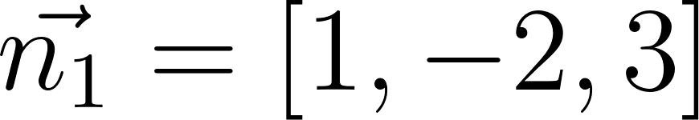](https://www.codecogs.com/eqnedit.php?latex=%5Cvec%7Bn_1%7D%3D%5B1%2C-2%2C3%5D#0)

[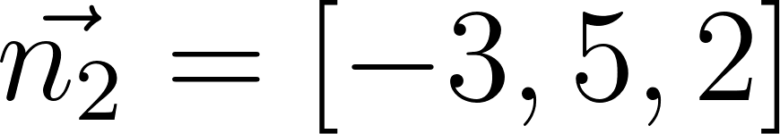](https://www.codecogs.com/eqnedit.php?latex=%5Cvec%7Bn_2%7D%3D%5B-3%2C5%2C2%5D#0)

[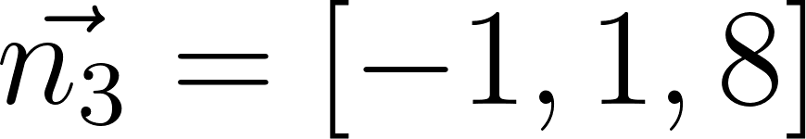](https://www.codecogs.com/eqnedit.php?latex=%5Cvec%7Bn_3%7D%3D%5B-1%2C1%2C8%5D#0)

We know the fact that if the scalar triple product is zero, it means the vectors are coplanar to each other. Thus, we are going to verify whether the given vectors are coplanar.

Thus, there are no intersection or infinite intersection points.

**8. Give the equations of three planes that meet in three lines. Explain your reasoning and include a LanGraph of your planes that allows you to see the triangular prism created.**

The normal vector of the three planes must be the same plane for the three planes to meet as three lines.

Let and

In this case, we can render the normal vectors as the following.

Since the constant terms of three planes cannot satisfy the relationship above, we can say that such constant terms to be added in the formula are the following.

The following is one of the examples of three planes with such normal vectors and constant terms.

